Intercast CR-39 (RTP USA)

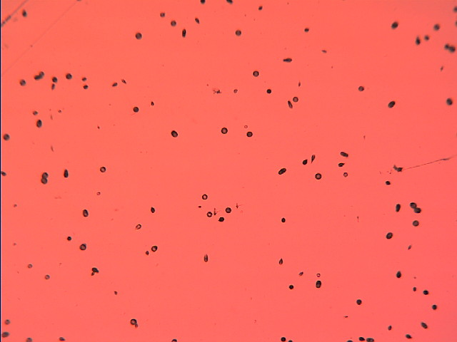

Image of tracks captured, after etching, with the microscope
in a CR-39 detector exposed to Radon gas

Calculate the track density (N° of tracks per cm²)

